**Name: Vismaya Mohan**

**Roll No: 54**

**Batch: B**

**Date: 6-4-2022**

**NETWORKING & SYSTEM ADMINISTRATION LAB**

**Experiment No.: 1**

**Aim**

Hardware Components

**Procedure**

**1.A Motherboard**

The motherboard is a circuit board that houses the processor, memory and ROM chips. Motherboards contain slots for additional cards as well as the bus connections that tie everything together and enable the other components to communicate with each other. They also contain integrated connection ports for hard disks, USB devices, modems, mice and keyboards. Most modern motherboards contain integrated network interfaces and modems.

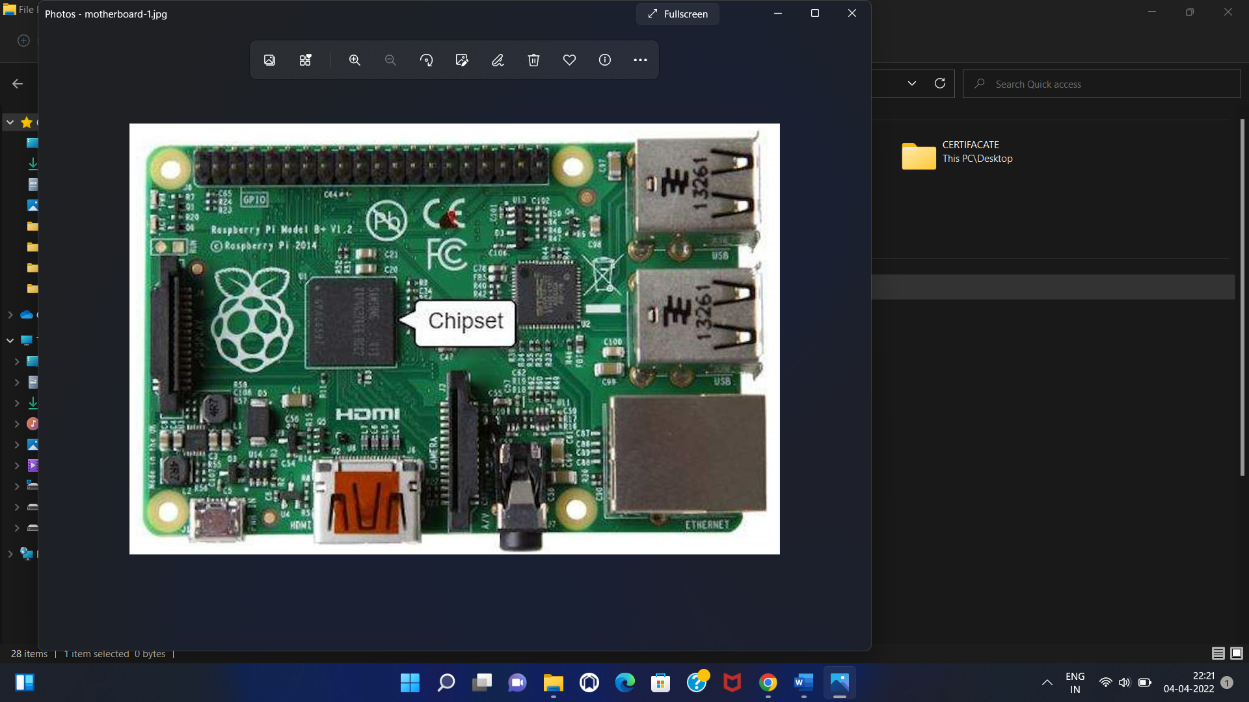

**2. Central Processing Unit (CPU)**

The CPU handles all computations and is a traffic cop for the entire machine, directing what happens and when. A CPU consists of the control unit, or CU, and the arithmetic logic unit, or ALU. The CU gets program instructions from the computer’s memory, deciphers them and executes them. The ALU does the math and makes decisions. CPUs exist in the form of a

silicon chip with millions of transistors. Some computers have more than one processor, and some chips contain more than one CPU.

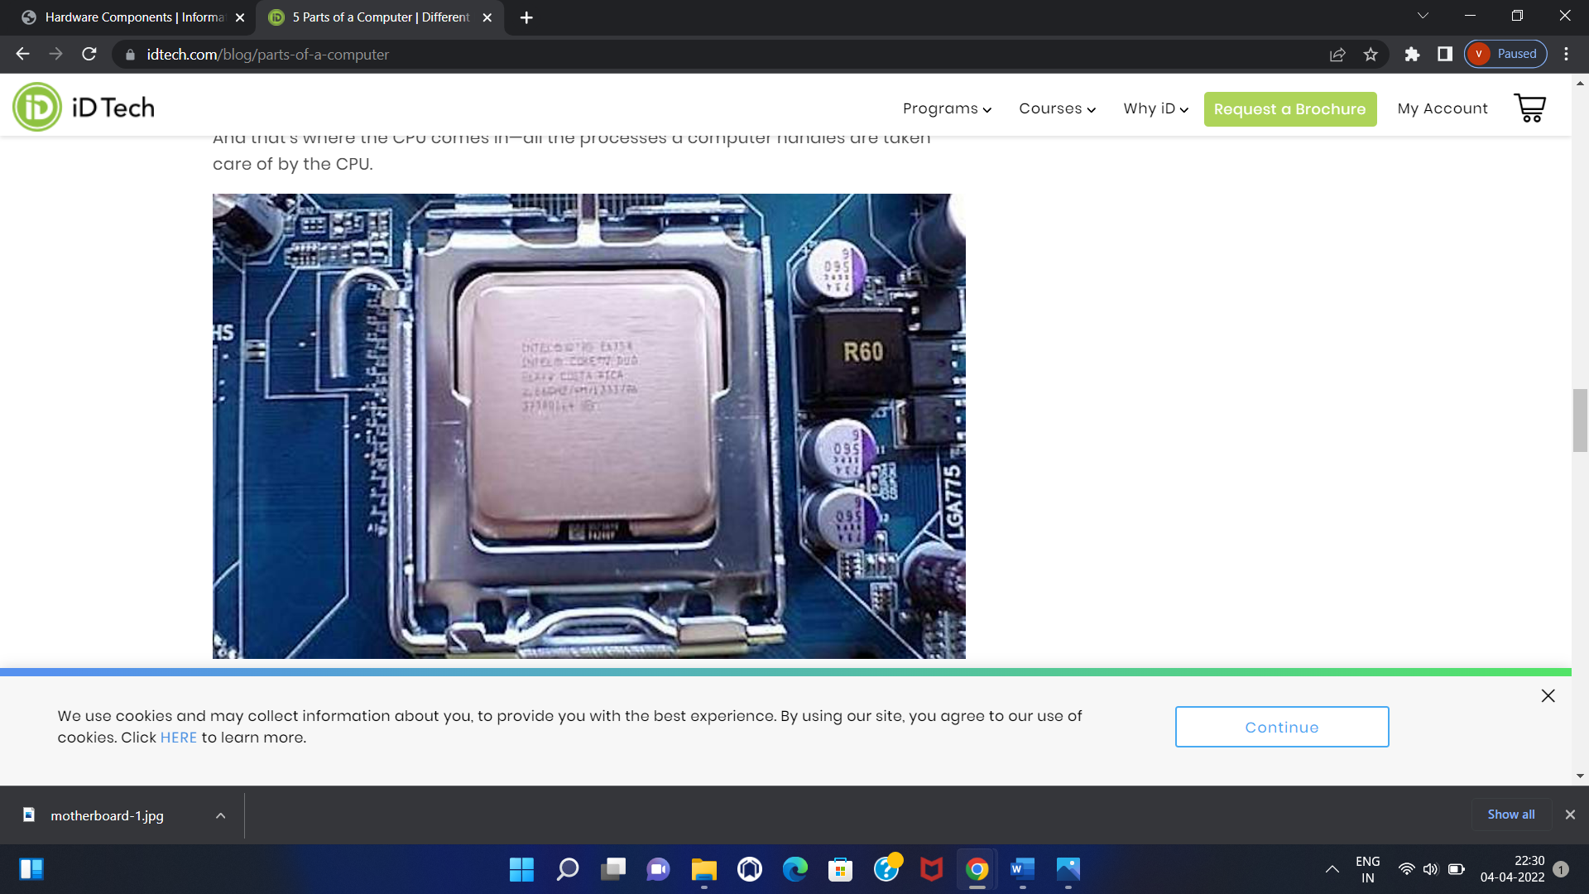

## 3.Random Access Memory

Random access memory is the primary storage for the computer. The CPU talks directly with RAM through a bus that connects all of the computer’s components electronically. RAM is very fast, operating in the nanosecond range, or billionths of a second. RAM is called volatile memory since it loses its contents when the power is removed. RAM, like the CPU, is made up of thousands or millions of transistors on a silicon chip.

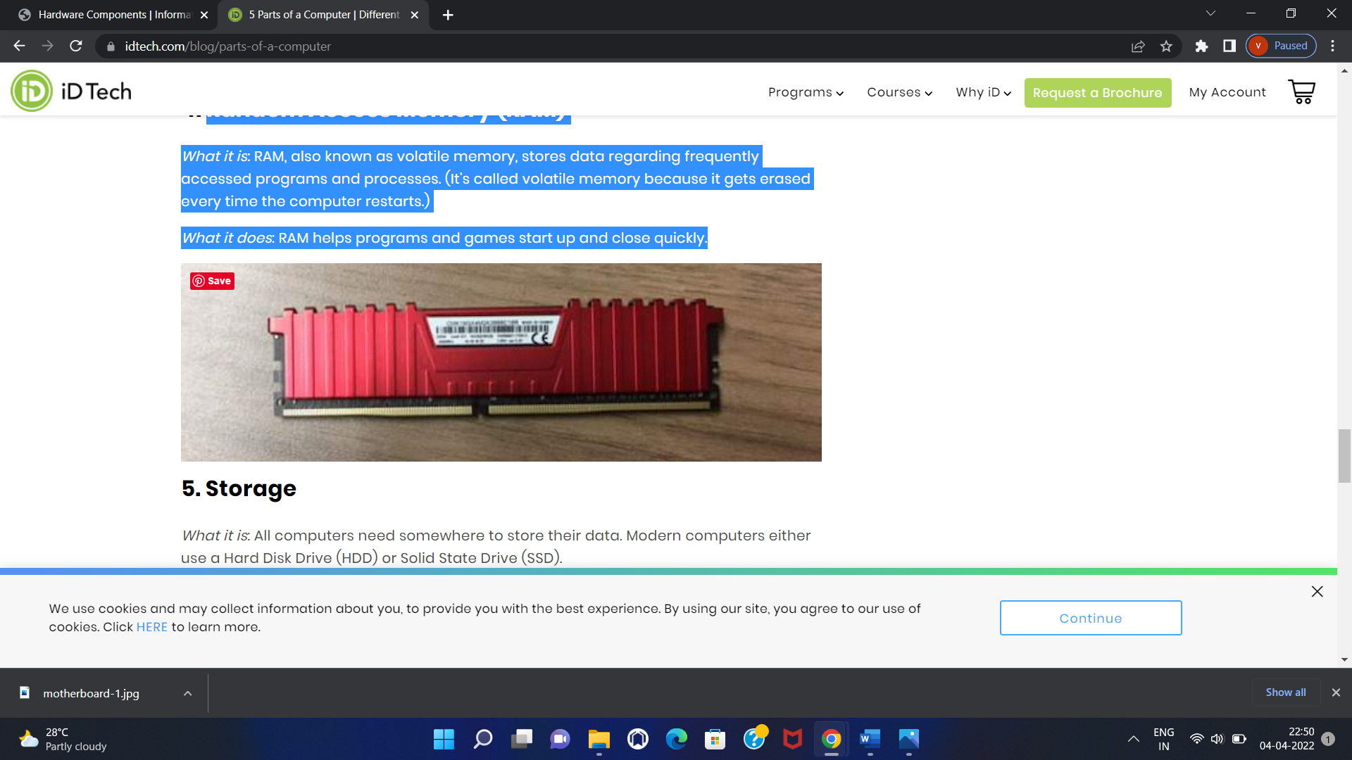

### ****4. Graphics Processing Unit (GPU)****

Another vital component of the computer is GPU. The Graphics Processing Unit or the video card helps generate high-end visuals like the ones in video games. Good graphics like these are also helpful for people who have to execute their work through images like 3D modellers and others who use resource-intensive software. It generally communicates directly with the monitor.

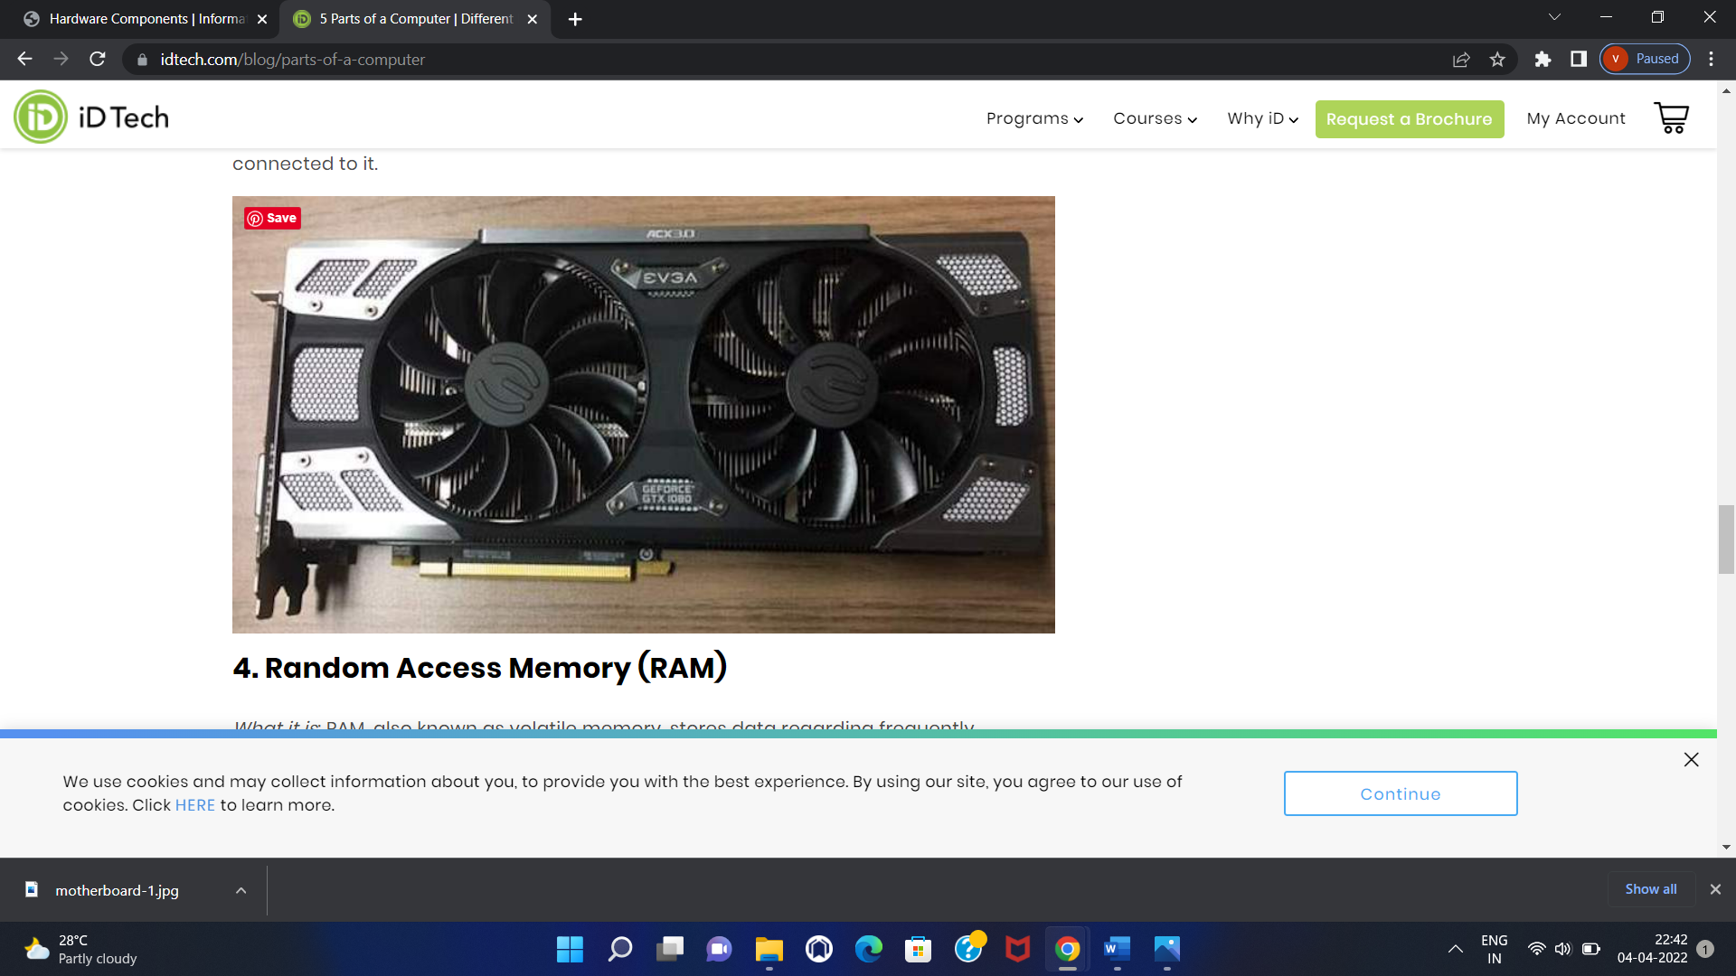

## 5.Read-Only Memory

Read-only memory, or ROM, stores pre-configured information for the computer that's usually used during the startup process. ROM chips are much like RAM chips, except the computer doesn't store information to ROM chips, but can only read from them. Some chips, such as the Basic Input-Output System are erasable read-only memory. These are also known as EPROM chips, and a special process is used to write new information to these chips. ROM chips are non-volatile, meaning they don't lose information when power is removed.

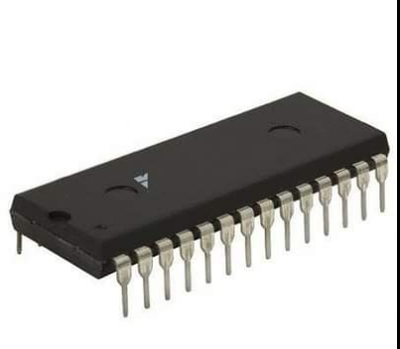

## 6.Secondary Storage

Since RAM is volatile and computers do not normally write to ROM, computers use a form of secondary storage called disk storage. Disks are small round platters with an oxide coating that can hold a magnetic charge. The charge for a particular spot on the disk can be either on or off, again supporting the computer language of 1s and 0s. Other forms of secondary storage include solid state disk, which is an array of non-volatile memory chips that mimic a normal disk. Flash drives are a form of solid state drive.

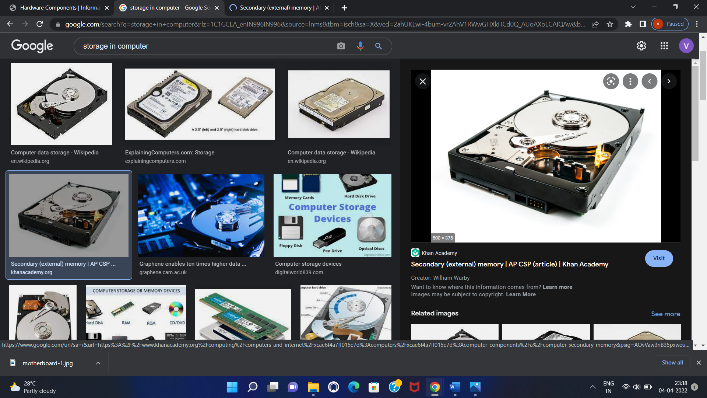

### 7.Control Unit

This is the core unit which manages the entire functioning of the computer device. It is one of the most essential components of the computer system.

The Control Unit collects the data entered using the input unit, leads it on for processing and once that is done, receives the output and presents it to the user. It can be said to the centre of all processing actions taking place inside a computer device.

Basically, the instructions taken, interpretation of entered data, issuing signals to execute the data and then finally retrieving the data is all done in the Control Unit.

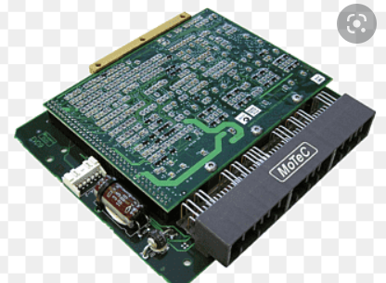

### 8. Memory Unit

When we enter the data into the computer using an input device, the entered information immediately gets saved in the memory unit of the Central Processing Unit (CPU). Because of the presence of some existing programming, the Memory Unit transmits the data further to the other parts of the CPU.

Similarly, when the output of our command is processed by the computer, it is saved in the memory unit before giving the output to the user.

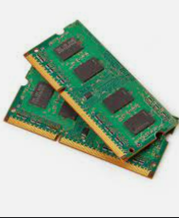

**9.Hard Disk Drive**

A hard disk drive (HDD), is a non-volatile storage device that stores digital data and works rapidly rotating platters with magnetic surfaces.  
Hard disk drives are a type of physical storage media that can be used to store lower amounts of data than other digital storage media such as flash drives.  
  
HDDs are the most common form of data storage for desktop and laptop computers.  
  
HDDs can be found in everything from robotics to space exploration and the medical industry.

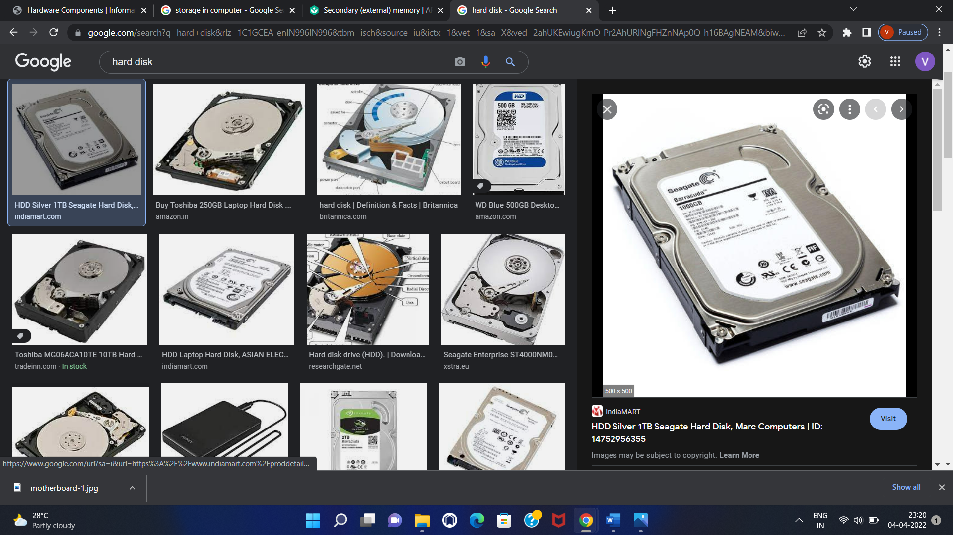

### 10. ****Power Supply Unit****

A Power Supply Unit (PSU) in a computer will generate power for the different components in the system, including the central processing unit (CPU) and RAM modules.  
  
The power supply has two electrical cables to connect to your motherboard.  
  
These are used to provide the voltage needed by the motherboard so that it can regulate all other voltages for other parts of the computer.

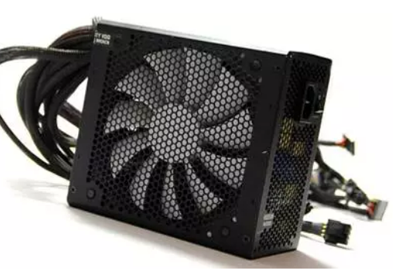

### 11. ****Solid State Drive (SSD)****

Computer components are not known for being cheap.  
And it's not always easy to figure out which ones are worth investing in.  
But there's one component that can make a big difference to your computer.  
Solid State Drives, or SSDs, are the new rage in computing.  
They're faster, more reliable, and much less vulnerable to physical damage than traditional spinning disks but SSD is expensive.

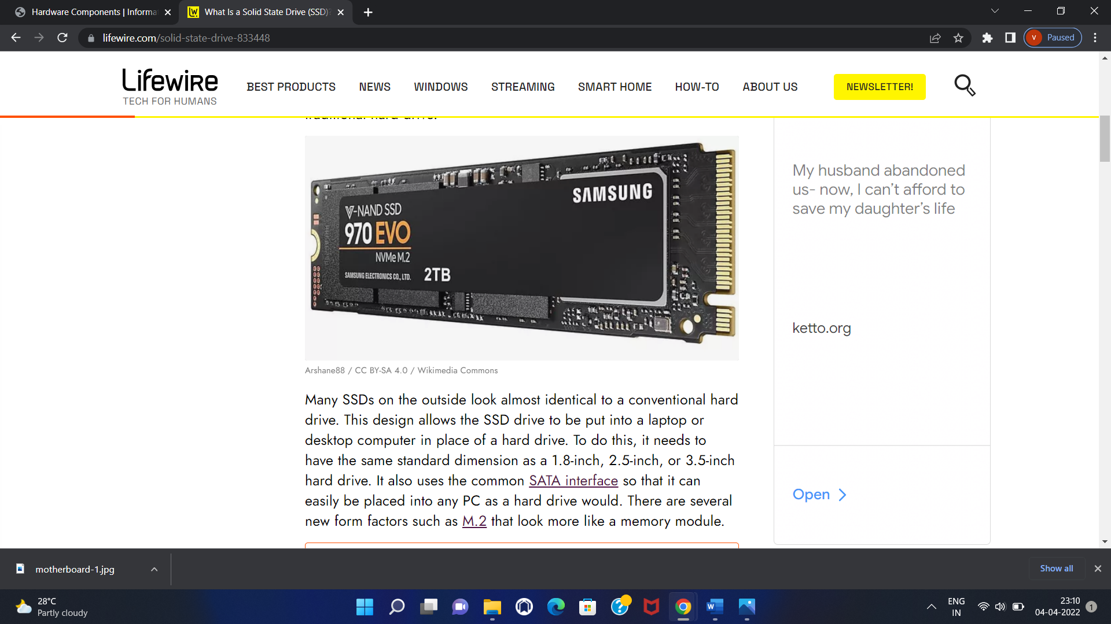

### ****12.Scanner****

Computer scanners are devices that convert images into digital or computerized information.  
The first scanners were large and expensive, but today they’re affordable and compact enough to fit on a desktop.  
A scanner allows you to copy anything from a picture to a receipt as well as images from magazines, newspapers, and books as long as it’s black and white.  
  
Scanners can be used for many purposes such as archiving family photos or creating an electronic form of your child’s artwork.

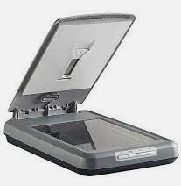

### 13. ****Optical Disc Drive****

An optical disc drive is a device that reads data from a CD, DVD, or Blu-ray disc. Usually, it's a part of the computer's hardware.  
In the early days of computers, floppy disk drives were popular.  
They read data from disks made of magnetic material coated with iron oxide.  
However now, most people have moved on to digital files stored on hard disks and USB flash drives.  
Optical discs (CDs and DVDs) still exist and many people like to use them to store their favorite music or movies.

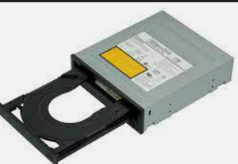

### ****14.Keyboard****

The keyboard is a device that consists of buttons, switches, or keys which are used to type out things on a computer.  
  
The keyboard is the primary input device of computers. The idea of a typewriter with a "keyboard" was first patented in 1886.  
  
In 1868, Christopher Latham Sholes developed the first working prototype of the typewriter.  
  
In 1888, he completed his work on an invention that became known as the "QWERTY" typewriter.

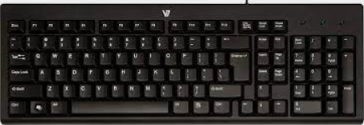

### 15. ****Printer****

Printers are the devices that you use to print documents. They can take paper and images and translate them into printed pages.Different printers will have different features, but all of them should allow you to print text, pictures, or other files that you’ve saved on your computer.  
Printers connected to a computer either with a USB cable or over Wi-Fi.  
Once it’s connected, you can use many different apps on your computer to print from.  
Printers typically have up to three ink cartridges that combine together to create the colors that form an image on paper.

